Guideline on admission to Degree Programs
of Kazan Federal University
If you plan to apply in Kazan Federal University (KFU), you have to go through several steps. Here is the detailed guideline on admission process, that is carried on the website “Budu Studentom!” (rus. Буду студентом) at https://abiturient.kpfu.ru/.

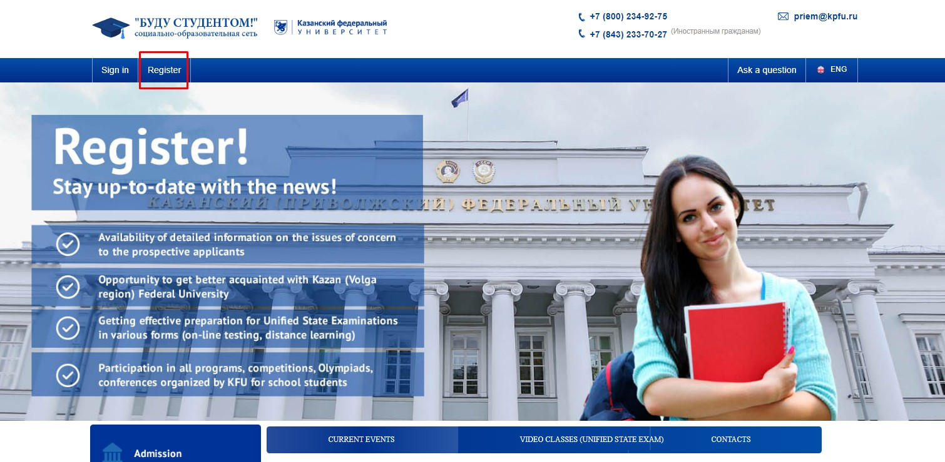
Step 1. Open your Internet browser. Go to the KFU’s website “Budu Studentom!” (abiturient.kpfu.ru). Click the button “Register” to start the process.

Step 2. In new window you have to fill your personal information. If you already have notarized translation of your passport, please fill all the fields in Russian according to it. Save your login (email) and pass, and do not lose that information, because you will need the access to the account during the whole admission process.

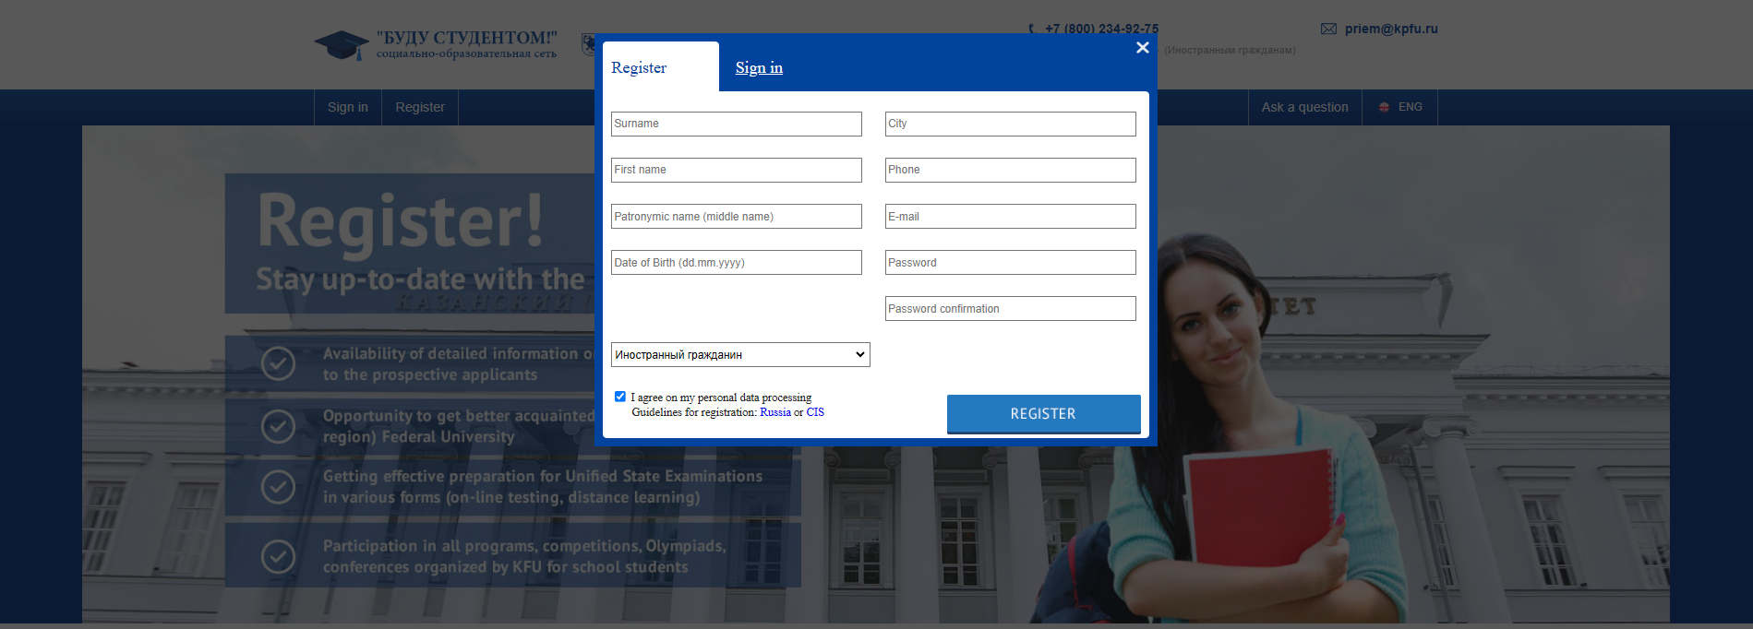

Step 3. To activate your account on website “Budu studentom” you have to open your email and follow the link in the letter of KFU Technical Support.
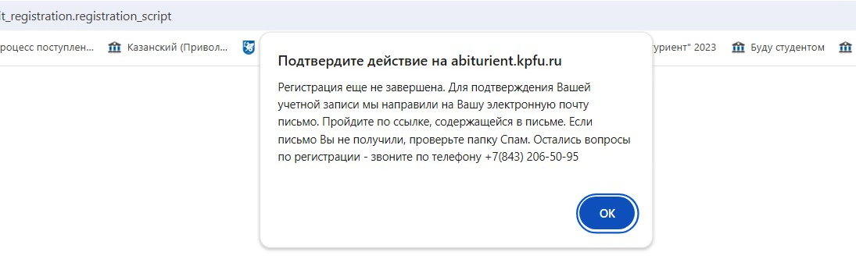

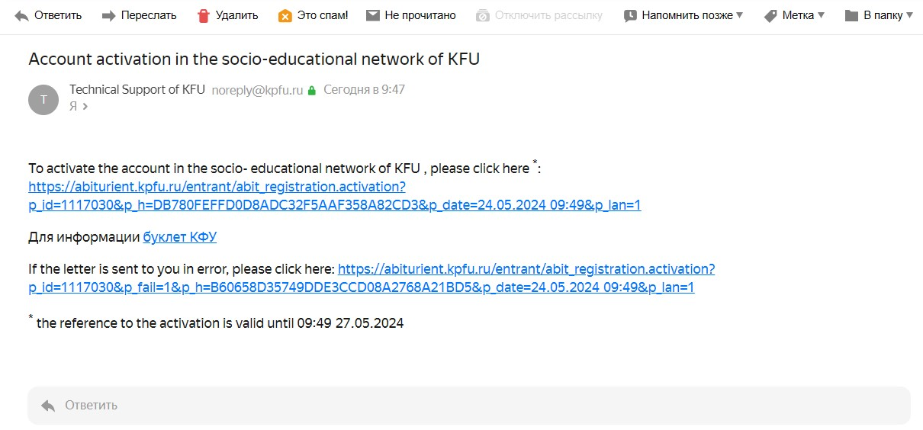

Step 4. Upon your first log-in you have to read the Agreement between the Participants of Electronic Interaction. Read, tick the box and click the button “Submit”.
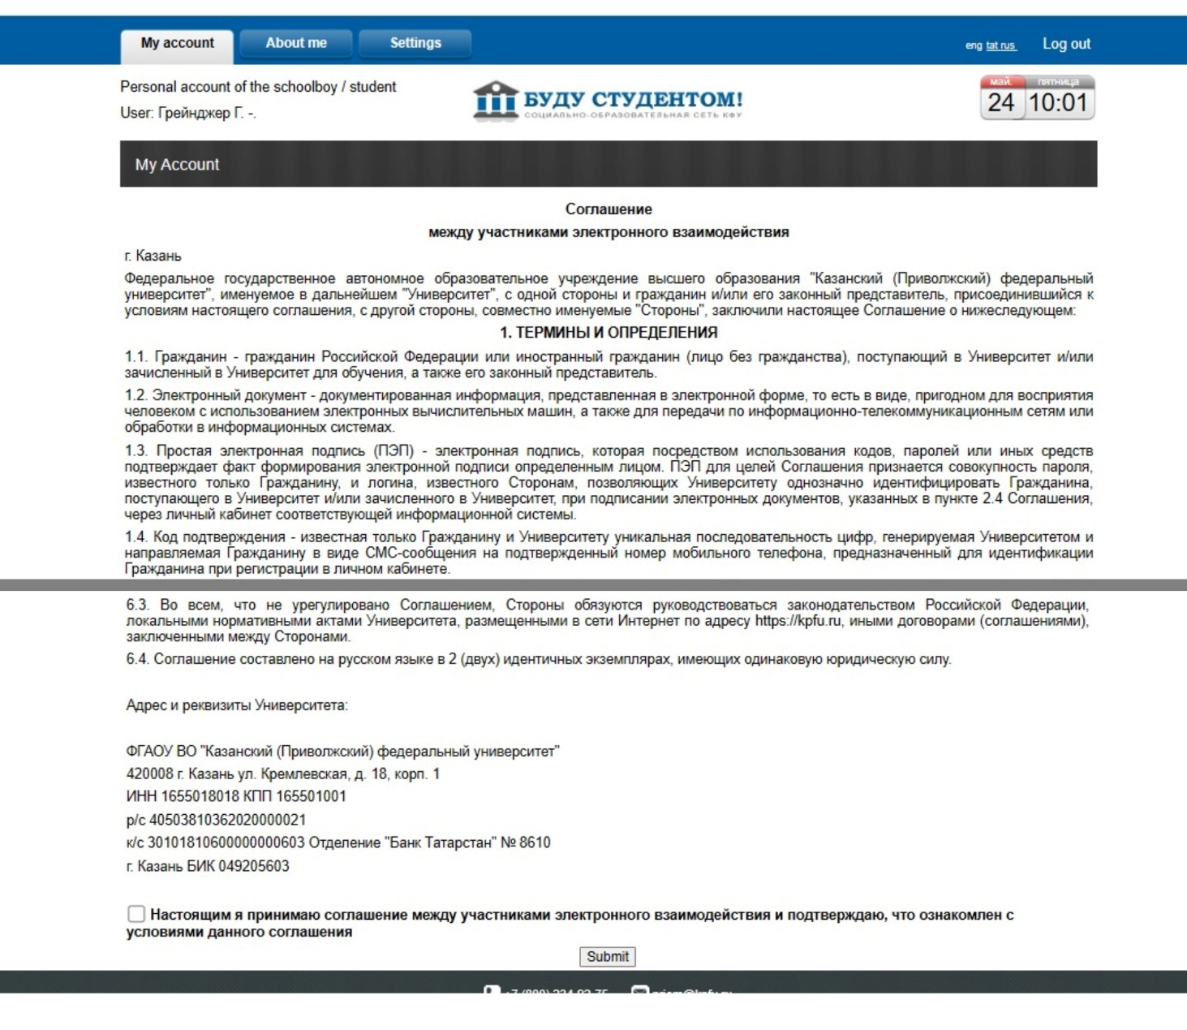

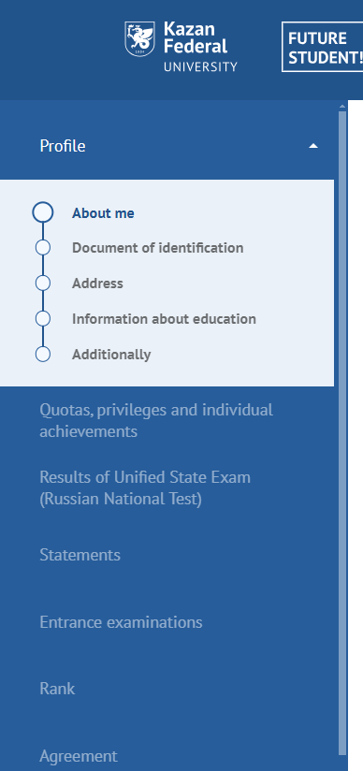
Step 5. Click on “Submit an application” in next window. Your application will consist of several parts, where you will have to fill in information and upload scanned documents in good quality and high resolution (300 dpi). File size limits is 10 mb.
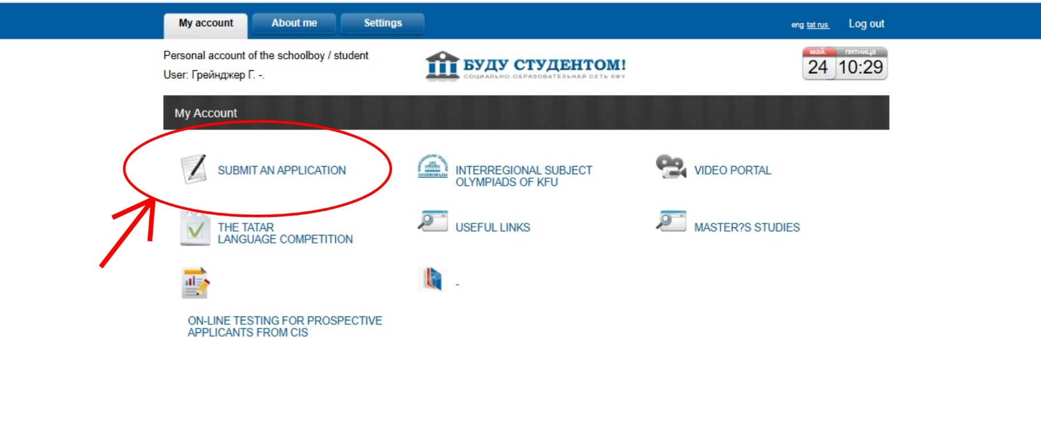

Prepare the scanned copy of your documents in advance:
1. International passport.
2. Notarized Russian translation of international passport
3. Document of education (diploma)
4. Document of education (transcript of records)
5. Notarized Russian translation of all documents of education with transcript of records
6. Certificate of recognition of educational documents (optional)
7. Photo (proportions 3x4 cm)

Step 6. Profile. About me.
1. Upload your photo with proportions 3x4 cm. It should be official photo with bright background. Selfie and casual photo will not be accepted.
2. Fill in your surname and name according to Russian notarized translation of your passport.
3. Fill in your contact information (email and phone).
4. If you are under 18 years old, you have to fill in information about your parents or legal representatives.
5. After filling information, click “Save” and then “Next”.
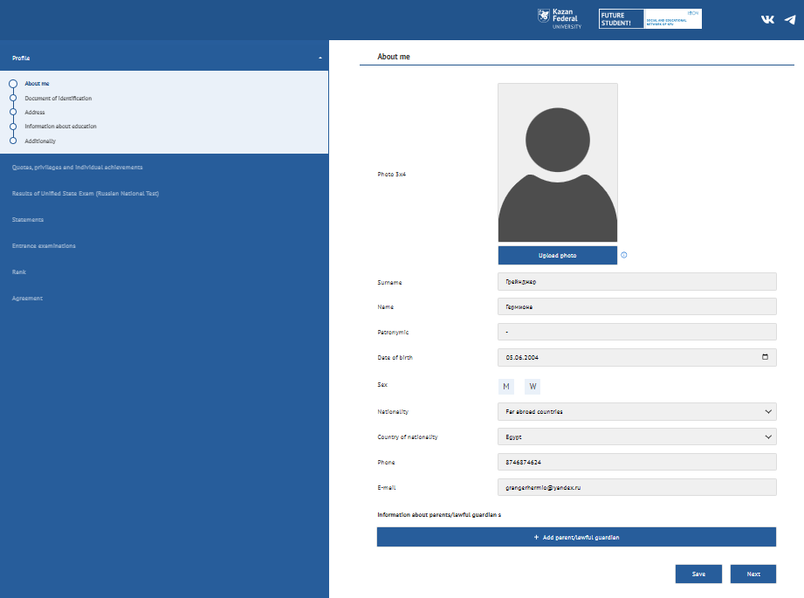
Step 7. Profile. Document of Identification.
1. Specify the type of your identity document and fill information on that document.
2. The name of the organization which issued the identity document must be written in Russian according to the notarized translation.
3. Please upload scanned documents in good quality and high resolution.
4. Do not forget to click “Save” and then “Next”.
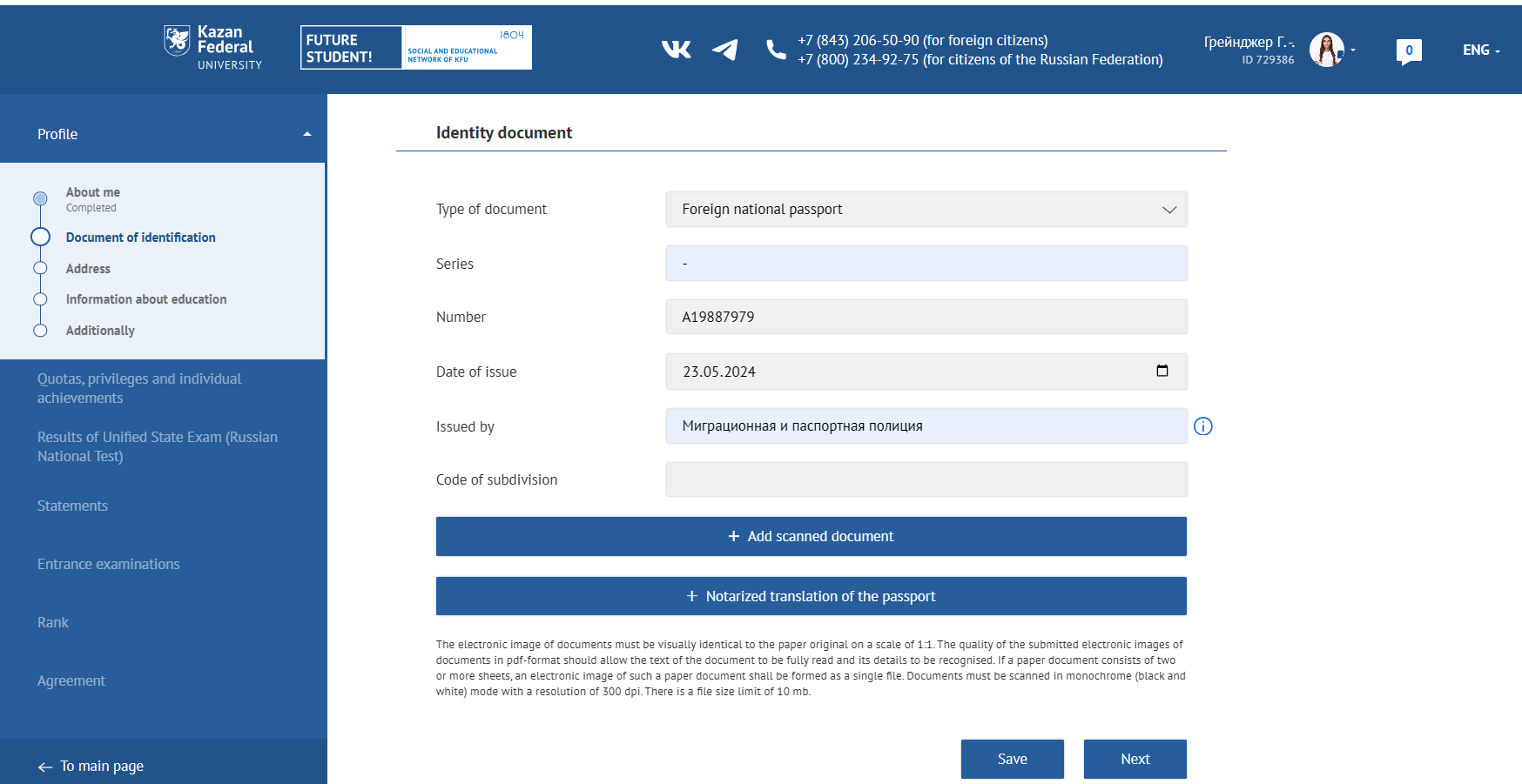

Step 8. Profile. Address.
1. Please fill in all the gaps of the address description.
2. Fill in the information in Russian (cyrillic alphabet), if possible.
3. Do not forget to click “Save” and then “Next”.

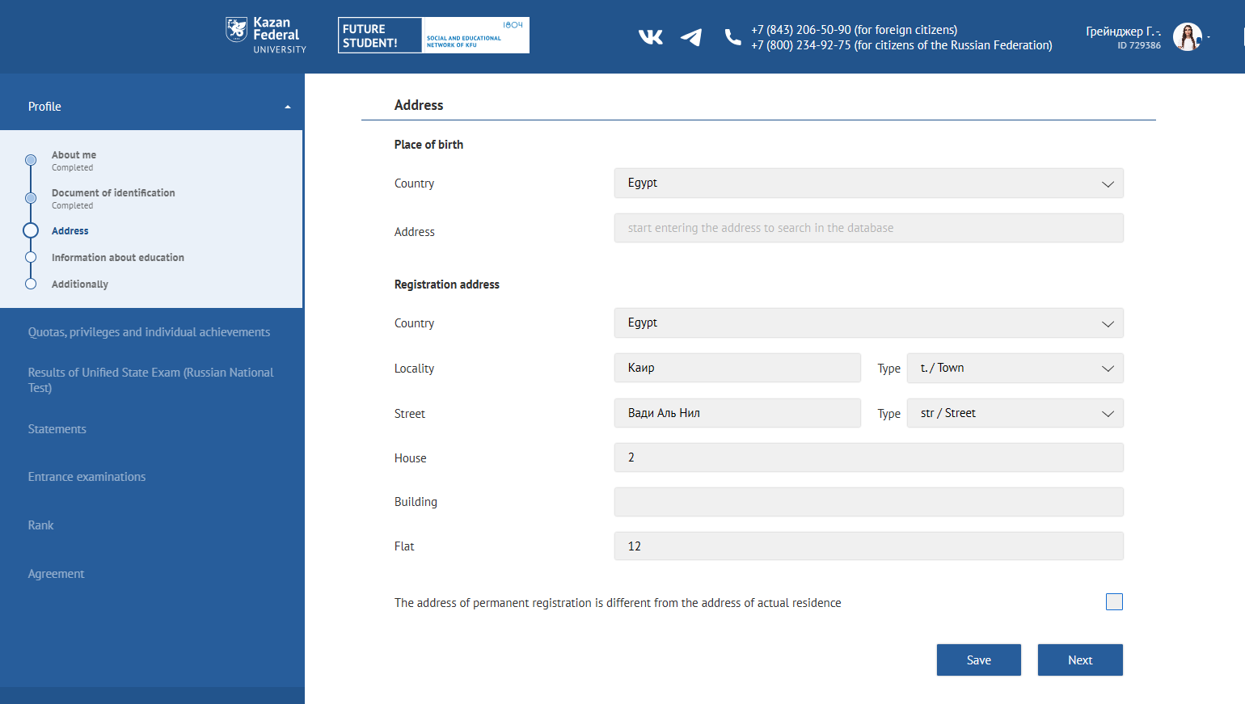

Step 9. Profile. Information about education.
1. Please fill in all the gaps of the education description.
2. The name of the educational institution must be written in Russian according to the notarized translation.

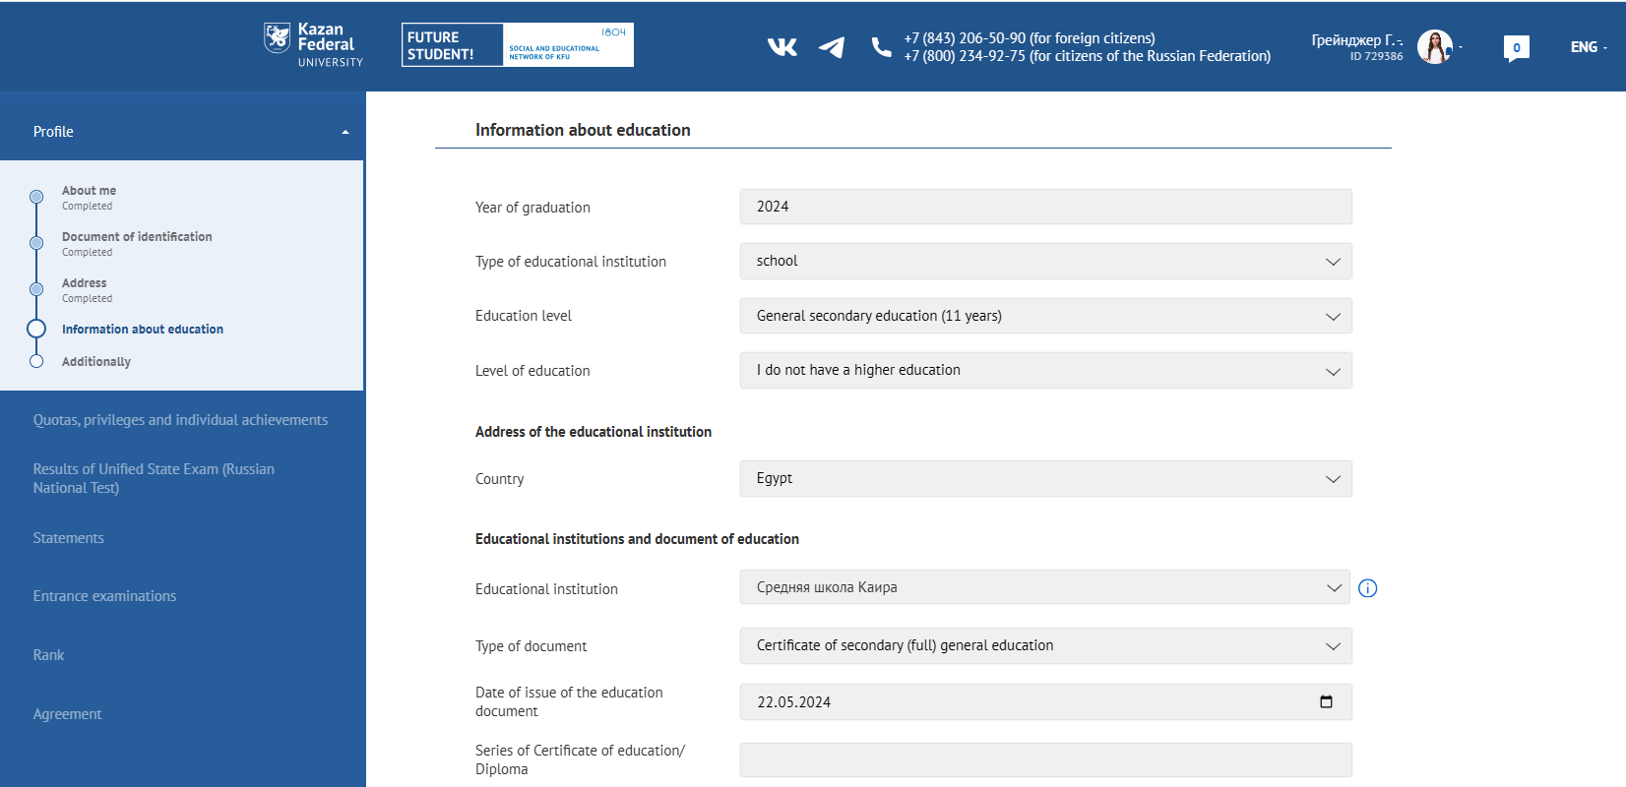

3. Please upload scanned documents of education in good quality and high resolution.
4. You have to upload notarized translation of educational document (diploma) and notarized translation of supplement (transcript of records) as ONE PDF in section “+Add scan of a notarized translation of an educational document”.
5. Check whether you need to undergo the recognition procedure on KFU web site https://eng.kpfu.ru/academic-recognition/. If you want to undergo the recognition procedure in KFU, please contact officer at the Department of External Affairs, SRTenisheva@kpfu.ru:
6. Choose the type of educational program. Tick the right one.
7. Do not forget to click “Save” and then “Next”.

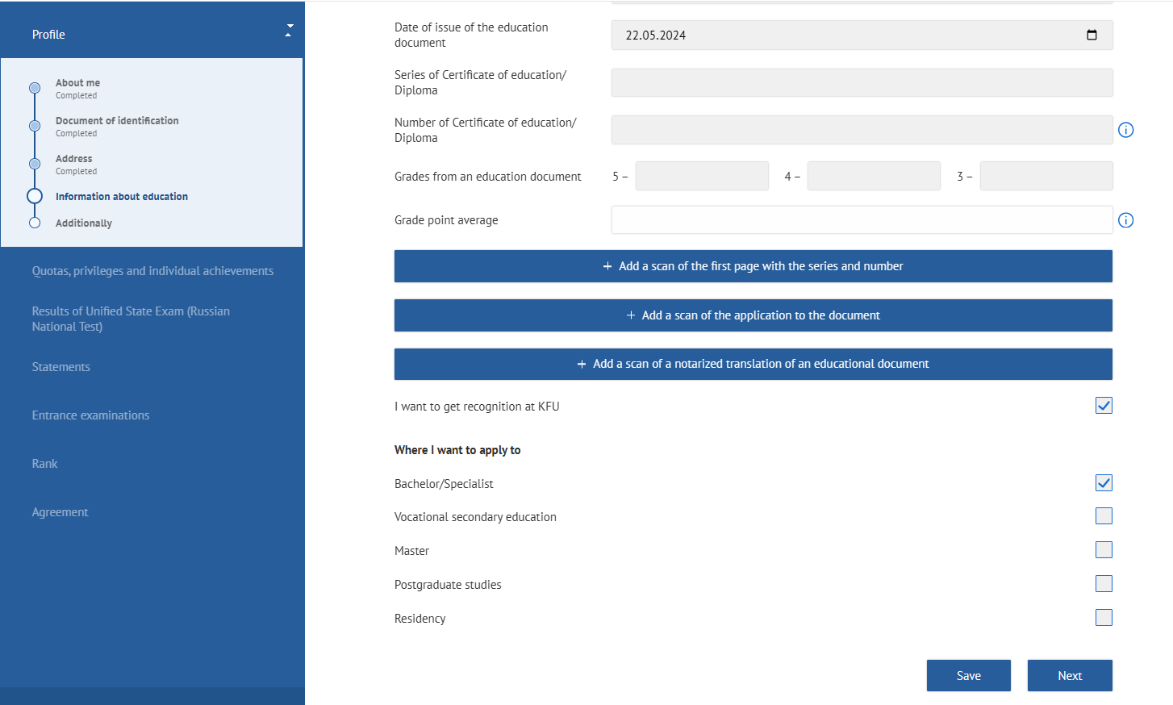

Step 10. Profile. Additionally.
1. Read and tick the box on Consent to Personal Data Processing. Sign the document with an electronic signature by clicking on “Sign”.
2. Specify how your application is submitted, independently or by agency.
3. If you need a place in a dormitory during the period of your studies, tick the appropriate box. Otherwise, please indicate the place of your stay.
If you need a place in a dormitory, read the regulations, sign the document with an electronic signature by clicking on “Sign”. Indicate if you have any benefits (priveledge) and attach a supporting document.
4. Read thoroughly the list of “Other” options.

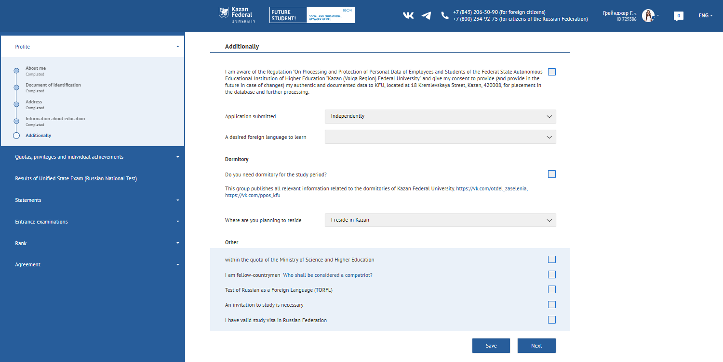

If you need to issue an invitation from KFU, tick the box and fill required information. Surname and first name in this item must be typed according to the international passport, in English. Mind the spelling!
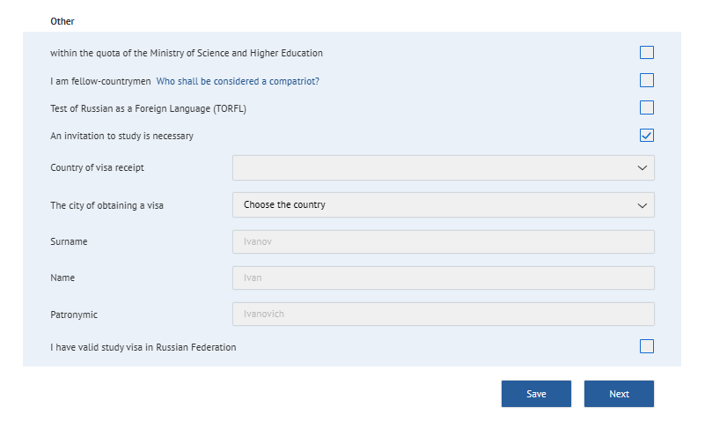

E) If you have valid study visa in Russian Federation, please tick the box, fill required information and upload the scan of your visa and educational certificate.
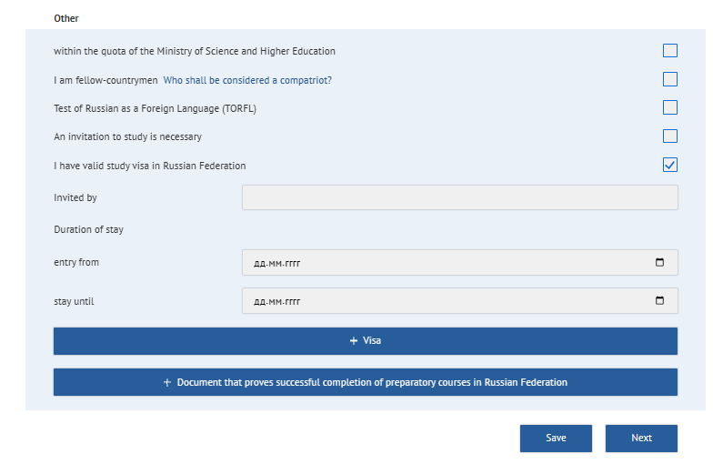

Do not forget to click “Save” and then “Next”.

Step 11. Quotas, Privileges and Individual Achievements. Privileges (Special Rights).
1. If you have any benefits (privilege), click “Add a benefit” and select the appropriate option from the list. It is necessary to fill in the form and attach the supporting document.
2. If you have no benefits (privileges), tick the "No privileges (special rights)" box.
3. Do not forget to click “Save” and then “Next”.

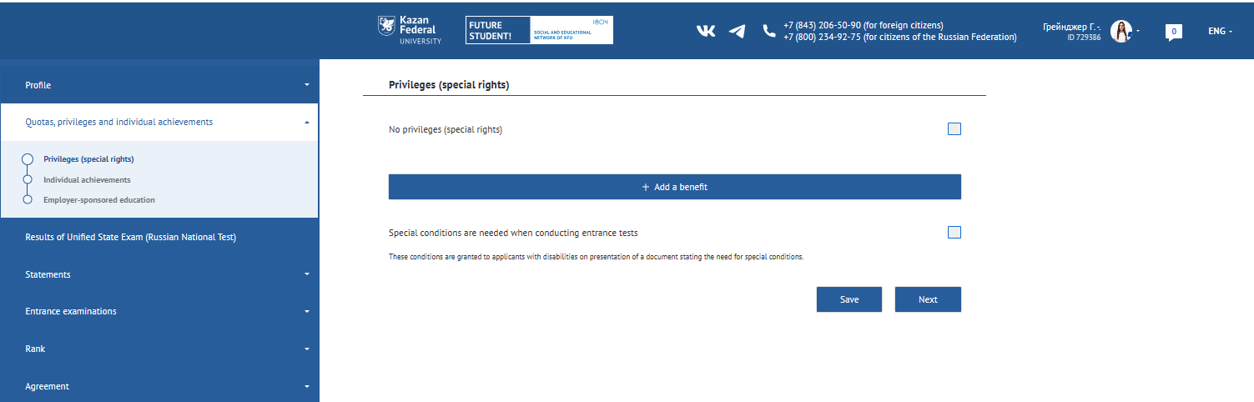

Step 12. Quotas, Privileges and Individual Achievements. Individual Achievements.
1. If you have personal achievements, click “Add individual achievement” and select an appropriate option from the list. You need to fill in the form and attach the supporting document.
2. If you have no individual (personal) achievements, tick the "No individual achievements" (Нет индивидуальных достижений) box.
3. Do not forget to click “Save” and then “Next”.

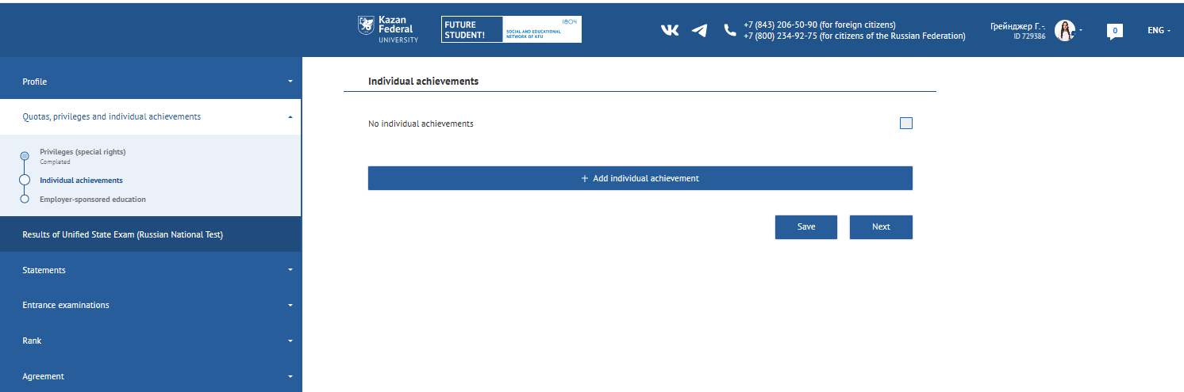

Step 13. Statements. Applications.
1. Select the type of application – Contract applications.
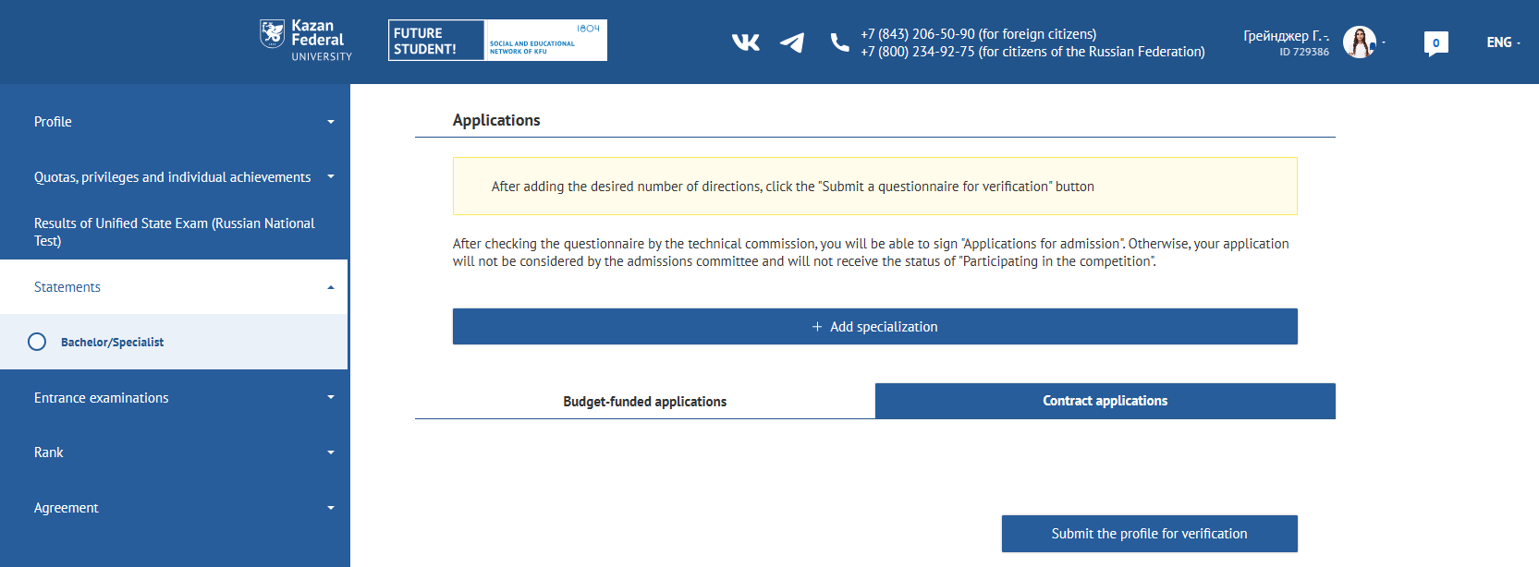
2. Click “Add specialization” and select direction of training and other details in new window.
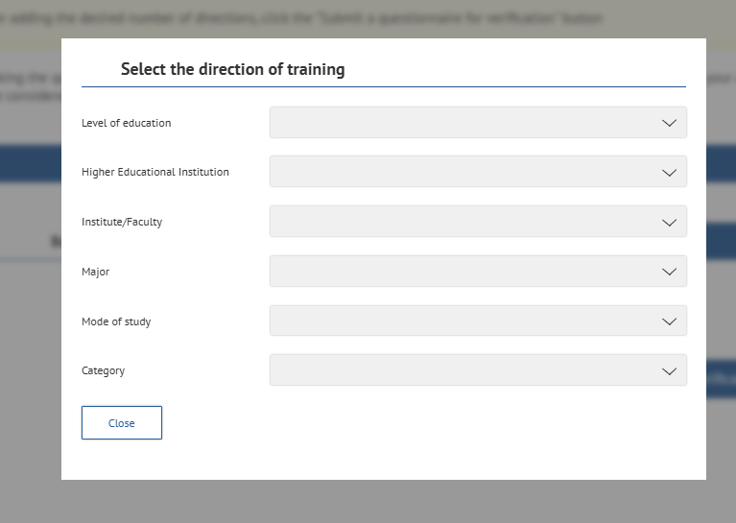

3. As soon as you finish, you will see next window. Here you can specify exams you want to take, type of exam and exam format (online or in person).
4. Tick the box confirming that you are familiar with the information of license for the right to carry out educational activities.
5. Do not forget to click “Save”.

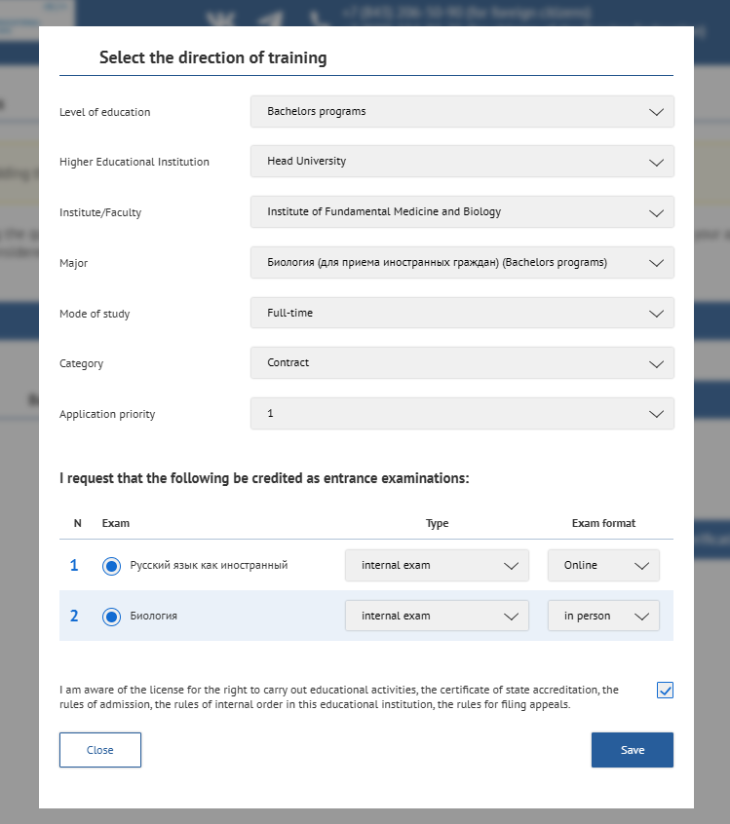

Step 14. To finish application process, you have to submit the profile for verification. Otherwise, your application will not be checked. If you want to change something, please click the button «Revoke» and repeat the actions described in previous step.
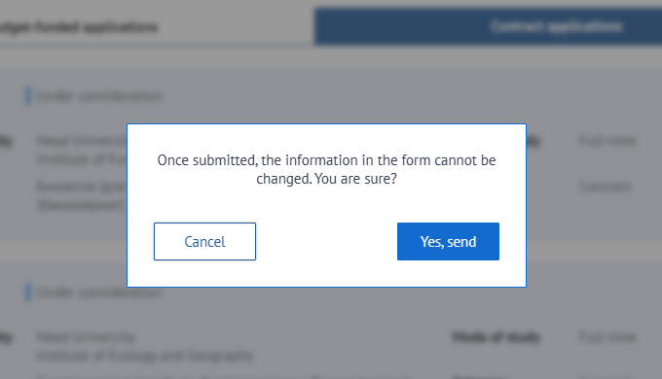
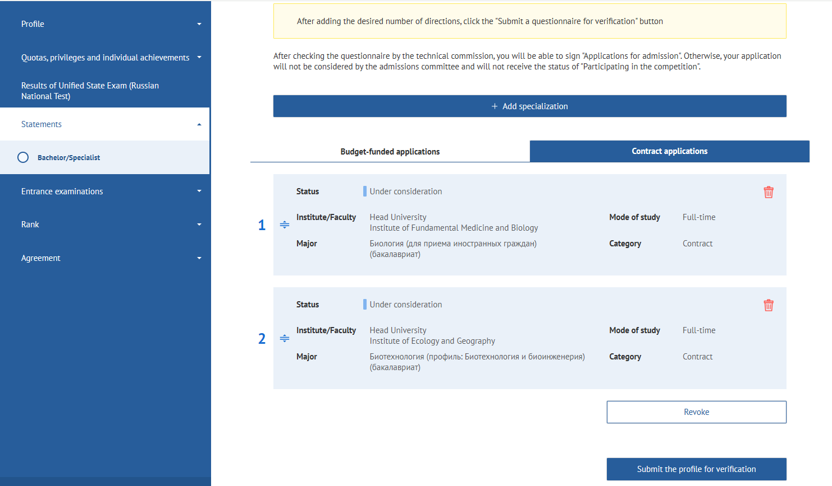

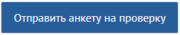

Step 15. Important information
1. If you made any mistake during the application process, or upload incorrect document, the section will have status “Must be revised”.
2. Do not forget to check the Notifications from the KFU.
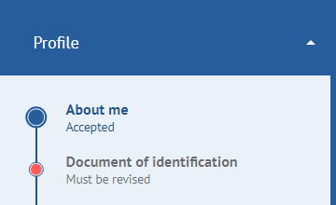
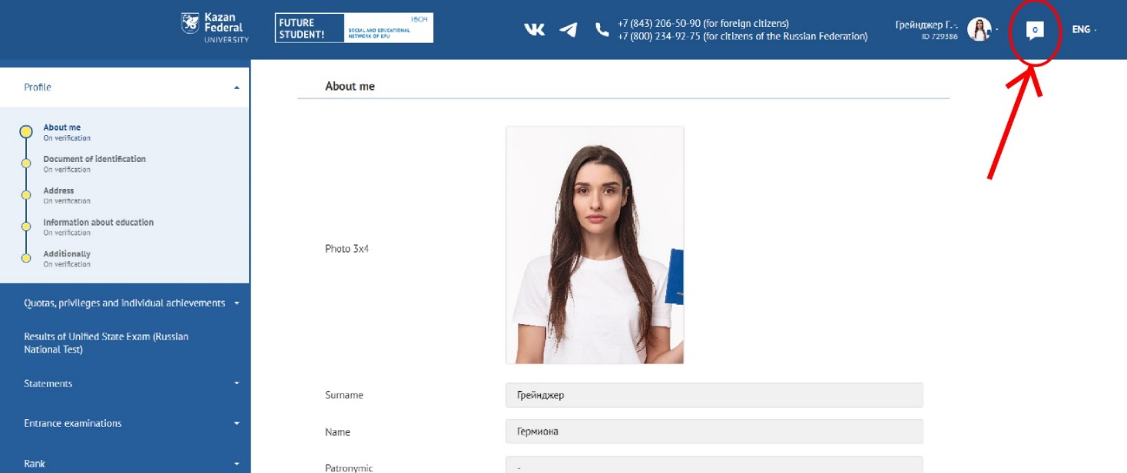

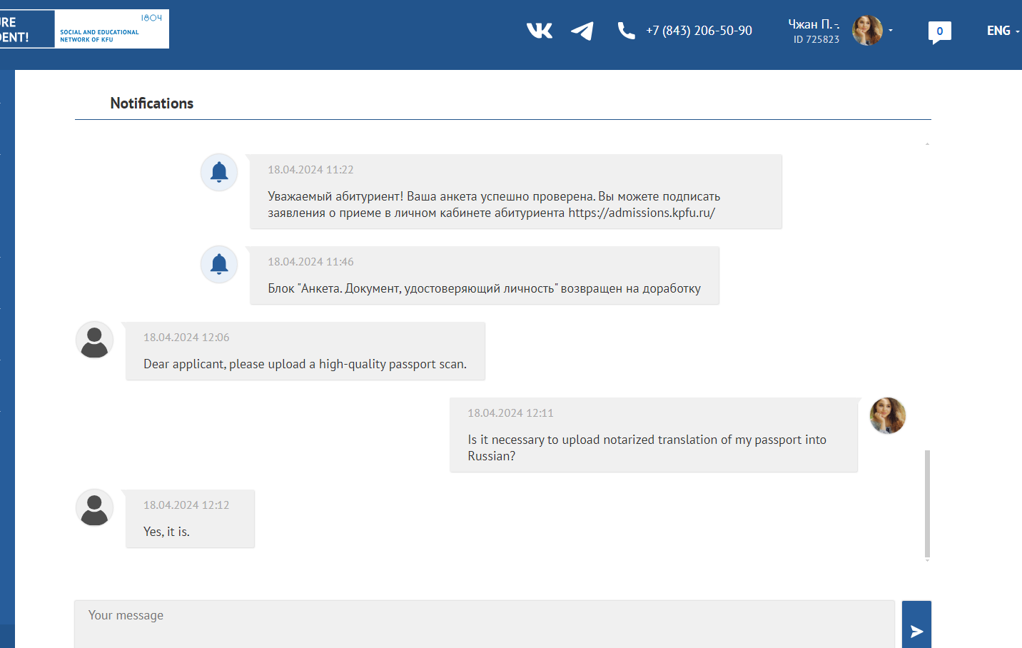

Step 16. When all information is accepted by KFU, you receive the right to sign up the Admission Applications in section “Application”. If you change your mind, you can revoke your application.
Attention! The application for consent to be enrolled in the budget-funded program (full-time and part-time education) can be signed only three times.
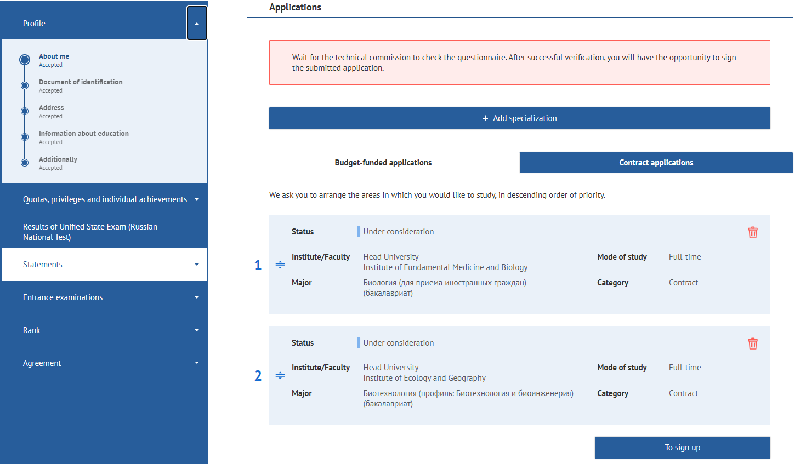

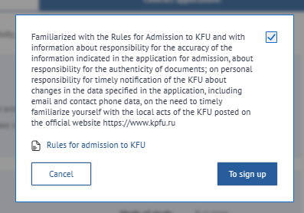
Step 17. Agreement issuing or providing the original document of education

Admission on contract form of education:
1. If your application is fully accepted and youк Olympiad result is good enough, you have the right to receive a contract and a receipt for tuition fees. The contract will be available in your personal account on the website "Budu studentom" within 14 days. Don't forget to attach a scanned copy of the payment receipt!
2. If you need to issue an invoice to pay for the training, write an email to admission@kpfu.ru or call 8 (843) 206-50-90, Admission office.

Step 18. Invitation for visa issuing
1. If you are a citizen of a visa country, you will receive an invitation to obtain a visa to enter the Russian Federation on the date of the start of your studies. The issuing of the invitation takes 40-45 days from the date of enrollment order implementation. Do not buy tickets in advance! A ready-made invitation will be sent to the email address that you specified in "Budu studentom".
2. If you have any questions about the invitation or visa, please contact the Visa and Invitation Department:
— contacts (https://kpfu.ru/international-relations/struktura/otdel-viz-i-priglashenij )
— information (https://kpfu.ru/invitations )

Step 19. Start of the education process
If you are a citizen of a visa country, on the first day of your stay in the Russian Federation you have to contact the Adaptation Department for foreign citizens:
— contacts (https://kpfu.ru/international-relations/struktura/otdel-vneuchebnoj-raboty/otdel-vneuchebnoj-raboty-2022.html)
— information (https://kpfu.ru/international/adaptation )

With the best wishes, your KFU!

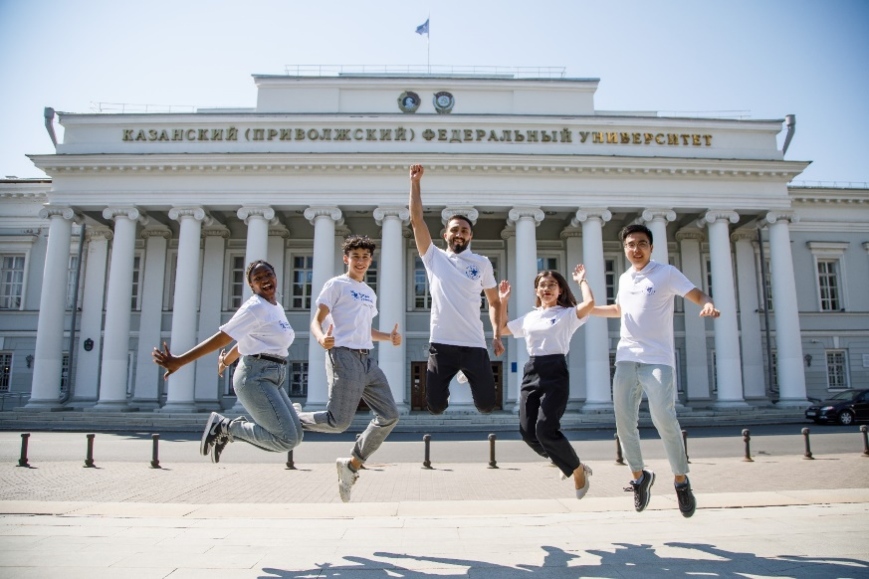

If you have any questions, please contact us: E-mail: admission@kpfu.ru (for emails)
WhatsApp: +7 (960) 049-18-76 (for text messages only) Tel. +7 (843) 2065090 (for calls only)

